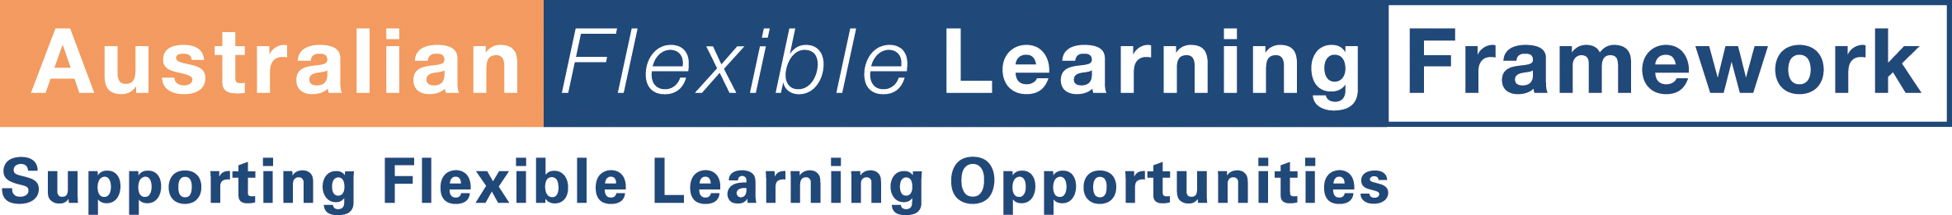

Attention: W3C

The Australian Broadcasting Corporation is conducting a project on behalf of the Australian Flexible Learning Framework in online moderation. The training resource is called “Building Communities” and will be developed for access by a standard web browser with the transport medium being typically the Internet, WWW or Intranet.

We seek permission to use as part of this development to link to your website. The items we are interested in are:

Title: “Finding your way at W3C”

URL: http://www.w3.org/2002/03/new-to-w3c

The “Building Communities” resources will be copyrighted to Australian National Training Authority (ANTA) and distributed to the National VET sector for free or at cost to assist in the delivery of training programs. The rights sought would in no way restrict republication of your work by you or by others authorised by you. If you are willing to grant this permission, we would be pleased to include suitable acknowledgement.

Many training products use Internet links and for ease of use, we would like to be able to direct readers straight to the relevant information rather than expecting them to navigate from the home page.

The final product will be made available by the Australian Flexible Learning Framework through the website: http://flexiblelearning.net.au and will be used by staff from Registered Training Organisation’s to assist in the delivery of training.

If you have any queries please do not hesitate to contact me.

We hope that you will be able to assist us with this request and look forward to your reply.

Melanie Sorensen
Program Leader
New Practices in Flexible Learning
newpractices@westone.wa.gov.au
WestOne Services
1 Prospect Place
West Perth WA 6005
Phone: 08 9956 6152 or 0428 566 152

December 6, 2003

